

TRAFFIC REGULATION NOTICE
ROAD TRAFFIC REGULATION ACT, 1984

Notice is hereby given pursuant to Section 14(2) of the Road Traffic Regulation Act, 1984, that the Oxfordshire County Council

TEMPORARILY PROHIBITS THE USE OF AND WAITING ON THE HIGHWAY
BY ALL MOTOR VEHICLES

LOCATION: Bampton, Buckland Road

REASON: to facilitate carriageway resurfacing works

DURATION: Starting on 20 April 2020
The anticipated completion date is 24 April 2020 (date included). This will operate between 04:00 and 18:00
(Traffic Regulation Notices cover a maximum of 5 consecutive days.)

ACCESS: limited access will be maintained for emergency service vehicles and for frontages within the closed section of road, subject to the progress of the works

The “No Waiting” restriction means that wherever there are in place yellow “No Waiting” cones, you will not be able to park vehicles on the highway.

SUGGESTED ALTERNATIVE ROUTE: via A4095, Radcot Road, London Street, A420, Buckland Road and vice versa
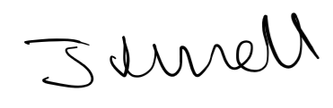
Jason Russell, Director for Infrastructure Delivery
Communities
Date: 16 March 2020

