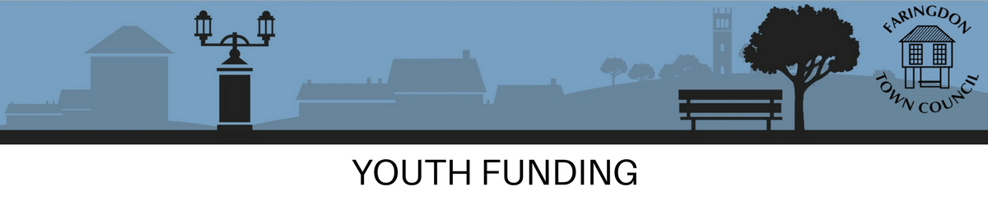

For applications normally up to £2000

HOW TO FILL IN THIS FORM
Please read the Youth Funding Policy before you complete this form.

Completion of all information required by this form is mandatory

1. Your Details

Name of Organisation
Project name
(if different from above)
Address of organisation
Legal Status of organisation  (please tick) | CIO | CIC | Unincorporated  Organisation | Other (please specify)
Contact name
(person with overall responsibility for this application)
Position held
Contact tel no. (day)
Contact email address
Project address
(if different from organisation address)
Name of the person who will be responsible for the project spend
Position held
What is the total cost of your project?
How much money is being requested from Faringdon Town Council?

2. About the Project or Activity You are Planning
Please describe what it is that you want to do with the grant.  (please keep your response to a maximum of 200 words)
  Delivery Start Date:
  Sessions Planned,
  e.g.: every Tuesday at 5pm:
  Location of Sessions:
  Number of young people attending each session:
  Project Completion Date:
How do you know there is a local need for the project or activity?

(Please keep your response to a maximum of 200 words)

How will you keep safe the children, young people and vulnerable adults you’ll be working with?
(Please provide a copy of your safeguarding policy with your application)

Please indicate if your group has public liability insurance.
(you should provide a copy of your public liability certificate with your application)

What other insurances does the group have?
(if any)

3. Meeting the Aims of the Council
Please choose the theme that relates to the Councils priorities from the list below to indicate which of the themes your application is being submitted under.

(please tick applicable box(es))
 | To tackle crime and anti-social behaviour in Faringdon |  | Provide a group that helps and supports Faringdon young people
 | To provide a youth festival and /or opportunity for young people in Faringdon |  | To meet the needs of vulnerable young people or those with special needs who live in Faringdon
 | An existing school council who wants to invest in local projects |  | An initiative that assists Faringdon young people in gaining employment, education and training

Tell us (in a maximum of 200 words) how the grant will help you achieve, all or part, of the theme you have selected. It is important that your application clearly links to at least ONE of the themes or it will not progress any further.

NB: The activities you wish to provide must be activities that are not currently provided by other agencies and /or is not replacing or duplicating other organisations responsibilities.

4. Financial Details of Your Organisation
Please provide the following details from your most recent annual accounts:
Please input data below, DO NOT refer to any attached documents
Account year ending
(Day / Month / Year)
Total (gross) income
Total expenditure
Balance at year end
Does your organisation have any reserves? If you have a reserves policy please send a copy with your application.
Financial reserves can be one of three types. General Reserves can be used to pay for any activity that furthers your organisation’s aims and objectives. Restricted Reserves are monies that must only be spent on a specific activity eg. funding awarded for an event or Designated Reserves are made when your organisation decides to put money aside for a later purpose eg. to replace equipment or refurbishment of a building.

General Reserves £………………….
Designated Reserves £………………….
Restricted Reserves £………………….
Total Monies Currently at Bank £………………….

If your reserves are more than your annual income, what are they for?

5. Financial Details of Your Project or Activity
Have you previously received funding from Faringdon Town Council for this project?
(please tick box)
Yes |  |  | No

Amount of grant sought from Faringdon Town Council | £

Faringdon Town Council will look more favourably on your application if you have match funding (eg other funding) towards the cost of your project and are not applying for 100% of your project costs.

Income sources for your project
Income / Funding source | Application submitted  Yes / No | Date when you expect a decision | 2020/2021  £
Faringdon Town Council  (applied for) | Yes

Total

Detail of Costs for your project
Please list expenditure items for your project (e.g. volunteer training, hire charges, fees). Your costs should add up & total the same as your income mentioned above.  NB: Faringdon Town Council will NOT fund retrospective expenditure that has already occurred or commenced. | 2020/21  £

Total

Reason for any deficit or high level of surplus
(if applicable)
How do you propose to fund the deficit
(if applicable)

Value of contributions in kind (c-i-k) e.g. volunteer hours/free use of room.

Anticipated c-i-k | Status | (Monetary equivalent)  £
Total

6. Value for Money
Would the grant (if agreed) attract funds or support from other sources?
If so how much and from where?
If you only received a percentage of the grant you requested tell us what you will be able to achieve based on:
75% of the grant request
50% of the grant request
25% of the grant request

7. Declaration
I declare on behalf of the organisation that the information in this form is correct.

Signed*
Date (day/month/year)
Name in block capitals
Position held
* If you are sending this form by e-mail you will need to print off this page, sign it and post it, with your supporting documentation to the Grants Officer.

Checklist of documents you need to send us (if you need guidance with any of the policies below, please contact Oxfordshire Youth):
Constitution or Aims and Objectives
A recent bank statement
Equal Opportunities statement

Reserves policy (if applicable)
Confidentiality or Data Protection Policy
Safeguarding Policy
Proof of affiliation to Oxfordshire Youth
8. Permissions
Your privacy is important to us.
We need to process your data to perform administration tasks.
We will comply with all data protection laws. We will only store your data for as long as we are legally required to do so.
You can find out more from our “Privacy Notice” which is available from our website or from the council Office or at www.faringdontowncouncil.gov.uk
Please confirm your consent below.
◻ Yes, I consent to Faringdon Town Council holding the data on this form for administration purposes only.

For office use only
Date Received
Date of Grant Meeting

Grant awarded

