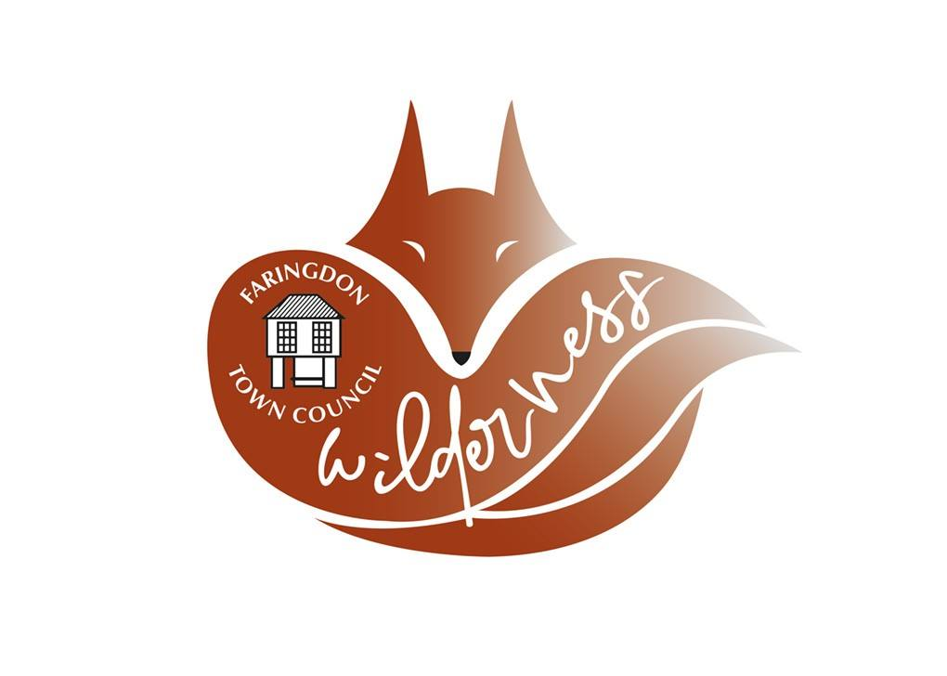

Volunteer for the Wilderness

  - Please note that unfortunately currently all volunteering is on hold due to the Coronavirus. However, if you are interested in volunteering in the future, please do complete the volunteer form and we will be in touch.

This information pack is for anyone who is interested in finding out more about being a volunteer for the Wilderness project and aims to explain everything you will need to know to offer your help.
The Wilderness also known as Willes Close triangle is an area in Faringdon recently designated as a wildlife area. People will be able to access the Wilderness to observe wildlife, to relax and for educational purposes.
We aim to protect wild animals and their habitat from destruction through education.
By raising awareness, we hope to educate young people to protect our environment. We are looking to engage members of our community from all backgrounds in new volunteering opportunities.

Are you interested in joining the Wilderness group in Faringdon?

Would you like to inspire people to get outdoors, get fit and work together to help your local wildlife thrive?
If so, we are looking for people with interest and care about the local wildlife while also increasing awareness and understanding that being active outdoors has physical and mental health benefits.
The Wilderness volunteers’ group aims at carrying out practical work conserving the wildlife of the Wilderness in Faringdon.
A Wilderness volunteer undertakes a wide variety of nature conservation work.
This can range from hedge laying to fence building; from tree planting to scrub clearance.
And work will also include wildlife, flora or fauna surveying.

Benefits to Volunteering include

Use your skills and knowledge to protect the Wilderness.
Do healthy exercise!
Have the opportunity to make new friends.
Gain professional experience.
It is a noble way to help your local community.

How can I help / What will be the main tasks of a Wilderness volunteer?

There are plenty of ways you can donate your skills and time to look after wildlife.
Opportunities include:
- Community gardening
- Species surveying
- Plant and animal identification and mapping
- Habitat protection and building
- Building bird and bat boxes and hedgehog housing
- Litter picking
Some other jobs not be directly with the wildlife, but they are just as important, and will keep the Wilderness functioning and working.

We are hoping to have a volunteer day at the Wilderness as soon as restriction allow.
Equipment will be made available.

If you are interested in joining the Wilderness volunteer group, please contact Marzia for more information: marzia@faringdontowncouncil.gov.uk

