A420 Faringdon - night-time closure and diversion route
27/28 November 2025 20:00 – 06:00
A420 between A417 and un-named road to Littleworth Village (Road Closure 20:00 – 06:00)
Div route: A420 – A415 – A338 – A417- Denchworth Road – A417

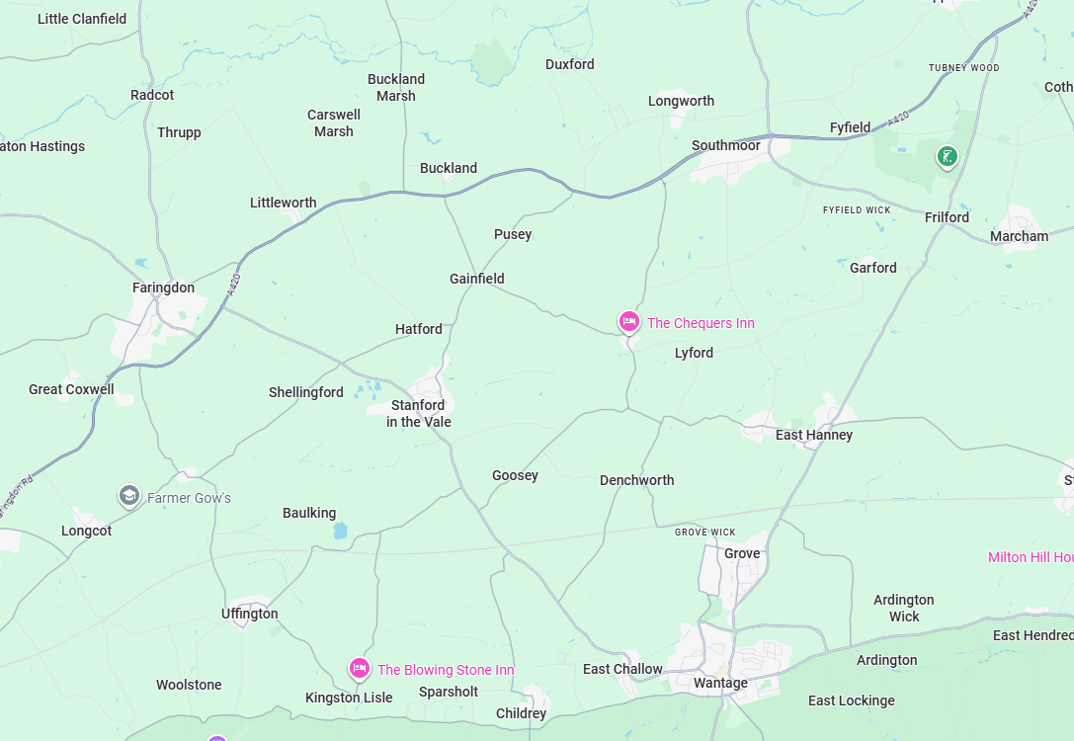
Road Closure
Diversion

